COIMBATORE INSTITUTE OF TECHNOLOGY
COIMBATORE

Department of Artificial Intelligence & Data Science

CertiChain: Decentralized Academic Certificate Verification Using Ethereum Smart Contracts

Project Report

Name: Mukesh V
Reg.no: 2303717624321035

Abstract
Academic credential fraud, slow manual verification and heavy administrative overhead are persistent problems for universities and employers. CertiChain is a decentralized web application that addresses them by combining client-side SHA-256 fingerprinting with an immutable Ethereum smart contract ledger. A certificate file (PDF, PNG or JPG) is hashed entirely inside the user's browser using the Web Cryptography API. Only the 64-character digest, together with the student name, course name, timestamp and issuer address, is written to the blockchain. The original document is never uploaded to a server or to public decentralized storage.
Only whitelisted institutions can register certificates, and they (or the contract owner) can revoke them. Anyone can verify a certificate through a read-only RPC connection, without MetaMask, a browser extension or any cryptocurrency. The system consists of a Solidity contract (CertificateVerification.sol) built and tested with Hardhat, and a React 19 + Vite front end that uses Ethers.js v6 with a dual-provider design. The contract is covered by 14 automated unit tests, and the platform runs on a local Hardhat network, with a roadmap toward Layer 2 deployment.
Keywords: Blockchain, Ethereum, Smart Contract, Solidity, SHA-256, Credential Verification, Hardhat, React, Ethers.js

1. Introduction

1.1 Background
A degree certificate is a high-stakes document: it influences hiring, admissions and immigration decisions. Yet verifying one is usually a manual, slow process involving emails or letters to the issuing institution. Forged and altered certificates are hard to detect by inspection alone, and institutions spend significant effort answering verification requests.
Blockchain technology offers a tamper-evident, publicly auditable and timestamped record. Storing full documents on-chain is impractical because of cost and privacy, but storing a cryptographic fingerprint of each document is cheap and effective.

1.2 Problem Statement
To design and implement a system in which:
- institutions can issue certificates that are provably authentic and timestamped;
- any third party can verify a certificate instantly, without trusting an intermediary and without needing a wallet;
- certificates can be revoked when issued in error or after misconduct;
- sensitive documents are never stored on a central server or on-chain.

1.3 Objectives
- Build a smart contract that registers, revokes and verifies certificate hashes with role-based access control.
- Compute document hashes locally in the browser so documents remain private.
- Provide an issuer portal for minting and revoking credentials and an owner-only administration tab.
- Provide a public verification portal that works by file upload, pasted hash or QR code.
- Validate contract behaviour with an automated test suite.

1.4 Scope
The current implementation targets a local Hardhat development network (Chain ID 31337) and demonstrates the complete issue, verify and revoke life cycle. Production deployment and extensions are described in Section 9.

2. Technology Stack
Layer | Technologies
Smart contracts | Solidity ^0.8.24, Hardhat, Ethers.js v6, Chai / Mocha
Front-end framework | React 19, Vite, React Router v7
Blockchain client | Ethers.js v6 (BrowserProvider + JsonRpcProvider)
Styling and UI | Pure CSS (glassmorphism, dark mode, responsive), Lucide icons
Utilities | Web Cryptography API (crypto.subtle), qrcode.react
Wallet | MetaMask (for issuers only)
Prerequisites for running the project: Node.js v18 or higher, npm and the MetaMask browser extension.

3. System Overview
CertiChain has three layers: the client browser, the blockchain layer and the actors who use them.
- Client browser: a React + Vite web app, a Web3 context provider, a SHA-256 engine based on SubtleCrypto, and the MetaMask injected provider.
- Blockchain layer: a JSON-RPC endpoint at 127.0.0.1:8545, the CertificateVerification.sol contract and the EVM state that stores the records.
- Actors: educational institutions (issuers) who upload a document and sign transactions, and verifiers (employers, recruiters, third parties) who upload a document or paste a hash.
The central design idea is separation of concerns. The document itself stays with the student. The blockchain stores only a fingerprint and minimal metadata. Verification is simply recomputing the fingerprint and checking whether the ledger knows it.

4. Core Components

4.1 Client-Side Cryptographic Engine
- Algorithm: SHA-256 via the native crypto.subtle.digest API, exposed through the utility generateSHA256(file), which returns a 64-character lowercase hexadecimal string as a Promise<string>.
- Privacy: the file is read into an ArrayBuffer in browser memory. It is never transferred over the network or written to a server, IPFS or Arweave.
- Tamper evidence: SHA-256 has 2^256 possible outputs. Changing even a single character or pixel produces a completely different digest (the avalanche effect), so an altered document fails verification immediately.

4.2 Smart Contract: CertificateVerification.sol
The contract (Solidity ^0.8.24, MIT licence) is the single source of truth for issued credentials.
Data structure
struct Certificate {
string studentName;
string courseName;
uint256 issueDate;
bool isValid;
address issuer;
}
State variables
Variable | Type | Purpose
owner | address | Administrator (deployer) who manages authorized issuers
isIssuer | mapping(address => bool) | True if an address may issue certificates
certificates | mapping(string => Certificate) | Maps a SHA-256 hash to its certificate record
Functions
Function | Access | Cost profile | Description
registerCertificate | onlyIssuer | State write (~90k gas) | Records hash, student, course and timestamp; reverts if already registered
revokeCertificate | onlyIssuer | State write (~30k gas) | Marks a certificate invalid; only the original issuer or the owner may do so
verifyCertificate | external view | Free (eth_call) | Returns validity, student, course, issue date and issuer
addIssuer | onlyOwner | State write (~45k gas) | Authorizes an institution address
removeIssuer | onlyOwner | State write (~30k gas) | Removes issuing privileges
Events
- CertificateRegistered(certHash, studentName, courseName, issueDate, issuer)
- CertificateRevoked(certHash, revoker)
- IssuerAdded(issuer)
- IssuerRemoved(issuer)
Revert conditions
Function | Message | Cause
registerCertificate | "Only authorized issuer can call this function" | Caller is not in isIssuer
registerCertificate | "Certificate already registered" | Hash is already valid on-chain
revokeCertificate | "Certificate is not valid or does not exist" | isValid is false
revokeCertificate | "Only the original issuer or owner can revoke" | Caller is a different issuer and not the owner
The verifyCertificate return value encodes three states: isValid == true means authentic and active; isValid == false with issueDate > 0 means revoked; isValid == false with issueDate == 0 means the hash was never registered.

5. Frontend Architecture

5.1 Dual-Provider Design
- Signer-connected provider (BrowserProvider): active when an institution connects MetaMask. It handles switching to Chain ID 31337 and dispatches state-changing transactions (registerCertificate, revokeCertificate, addIssuer).
- Read-only failover provider (JsonRpcProvider): connects directly to http://127.0.0.1:8545. Verifiers, employers and candidates can verify credentials without MetaMask, extensions or cryptocurrency balances.

5.2 Web3 Context
The useWeb3() hook, provided by Web3Context.jsx, centralizes wallet and role state.
Property / method | Description
account | Connected wallet address (lowercase)
contract | Signer-connected contract for write transactions
readContract | Read-only contract for wallet-free queries
isIssuer, isOwner | Role flags for the connected account
isCorrectNetwork | True when connected to Chain ID 31337
rpcConnected | True when the local node is responsive
connectWallet(), disconnectWallet() | Wallet connection control
switchToHardhatNetwork() | Asks MetaMask to switch to or add the Hardhat network
refreshIssuerStatus() | Re-evaluates on-chain roles for the current account

5.3 Role-Based Access in the UI
- Public: Home (/) and Verification (/verify/:hash).
- Authorized issuer: Issuer Portal (/issuer) to mint credentials, revoke them and view receipts.
- Contract owner: an additional Admin tab to authorize or remove institutions.

5.4 Repository Structure
blockchain-project/
├── docs/ # Architecture, API reference, setup, user manual
├── frontend/
│ └── src/
│ ├── artifacts/ # Compiled contract ABIs
│ ├── components/Navbar.jsx
│ ├── config/ # contract.js, contractAddress.json (auto-generated)
│ ├── context/Web3Context.jsx
│ ├── pages/ # Home, IssuerDashboard, VerifyCertificate
│ ├── utils/hash.js
│ ├── App.jsx
│ └── index.css
└── smart-contracts/
├── contracts/CertificateVerification.sol
├── scripts/deploy.js # Deploys and syncs address to the frontend
├── test/CertificateVerification.test.js
└── hardhat.config.js
The deployment script writes the deployed contract address into frontend/src/config/contractAddress.json, so the front end always points to the latest deployment.

6. Workflows

6.1 Certificate Issuance
- The registrar connects MetaMask with an authorized issuer account and opens the Issuer Portal.
- The registrar enters the student name and course or degree, and uploads the certificate file.
- The browser calculates the SHA-256 hash locally.
- The registrar clicks Register Certificate on Blockchain; MetaMask asks for approval of the transaction and gas fee.
- The contract checks the onlyIssuer modifier and that the hash is not already valid, stores the Certificate struct and emits CertificateRegistered.
- The browser shows the transaction receipt, block number and a verification QR code that can be printed on the diploma.

6.2 Verification
- The verifier uploads the document on the Home page (or pastes a 64-character hash, or scans a QR code that opens /verify/<hash>).
- The browser hashes the file locally and sends an eth_call to verifyCertificate(hash) through the read-only RPC provider.
- The result is shown as one of three outcomes:
Outcome | Condition | Message
Green badge | isValid == true | "Verified Authentic" with student, degree, issue date and issuer address
Orange/red badge | isValid == false and issueDate > 0 | "Certificate Has Been REVOKED"
Red badge | isValid == false and issueDate == 0 | "Verification Failed": the file does not match any registered hash and may be altered or forged

6.3 Revocation
- In the Issuer Portal, open the Revoke tab and paste the certificate hash.
- Click Look Up and confirm the student and course details.
- Click Confirm Revoke on Blockchain and sign the transaction.
- The contract sets isValid = false while retaining the original issuance metadata, so later verifications show a clear revoked warning and the audit trail is preserved.

6.4 Institution Authorization
The contract owner opens the Admin tab, enters the Ethereum address of a college, university or examination board and clicks Authorize Address to grant minting rights. The same tab can remove an institution's privileges.

7. Security Analysis
Threat | Mitigation in CertiChain
Document forgery or alteration | Any change produces a different SHA-256 hash, so verification fails with "Not Found"
Unauthorized minting | The onlyIssuer modifier rejects non-whitelisted callers
Impersonation of a university | The issuer's Ethereum address is recorded on-chain; verifiers can compare it with the university's known public address
Tampering with revoked diplomas | Revocation sets isValid = false on-chain and preserves the issuance record for auditing
Replay or duplicate registration | require(!certificates[_certHash].isValid, "Certificate already registered") prevents overwriting
Network and privacy leaks | No document is stored on-chain or on any server; hashing is 100% client-side
The trust model is explicit: the system trusts the contract owner to whitelist only genuine institutions, and verifiers must know which issuer address belongs to which institution.

8. Testing
The smart contract is tested with Hardhat, Chai and Mocha. Running npm test in smart-contracts executes 14 unit tests, all of which pass.
Area | Test
Deployment | Deployer is set as owner
Deployment | Owner is authorized as an issuer by default
Issuer management | Owner can add a new issuer
Issuer management | Non-owners cannot add an issuer
Issuer management | Owner can remove an issuer
Issuer management | Non-owners cannot remove an issuer
Registration | Authorized issuer can register a certificate
Registration | Unauthorized accounts cannot register
Registration | The same hash cannot be registered twice
Verification | Unregistered hashes return false
Revocation | Original issuer can revoke
Revocation | Contract owner can revoke any certificate
Revocation | A different issuer cannot revoke someone else's certificate
Revocation | Already revoked or non-existent certificates cannot be revoked
The tests cover the contract's deployment, access control, registration, duplicate detection, verification and revocation behaviour. The front end was exercised manually through the issue, verify and revoke workflows described in Section 6.

9. Setup and Deployment
Smart contracts
- cd smart-contracts and run npm install.
- Run npm test to confirm all 14 tests pass.
- Start the local blockchain with npx hardhat node. It listens on http://127.0.0.1:8545 and provides 20 pre-funded test accounts.
- In a second terminal, run npm run deploy to deploy the contract and write its address to the front-end config.
Front end
- cd frontend, then npm install.
- Run npm run dev and open http://localhost:5173.
MetaMask configuration (issuers only): add the network with RPC URL http://127.0.0.1:8545, Chain ID 31337 and currency symbol ETH (the front end can also prompt to add it). Import Hardhat's Account #0 as a test account, which is the contract owner and default issuer. This is a publicly known development key and must never be used on a real network.
Troubleshooting
- "Node Offline" banner: the Hardhat node is not running.
- "Unauthorized Account": only addresses added by the owner can mint, so switch to an authorized wallet.
- "Certificate already registered": this exact file hash is already on-chain.

10. Limitations
- Local network only: the read-only provider is pointed at 127.0.0.1:8545, so verification currently works only where the local node is reachable.
- Public metadata: student name and course name are stored in plain text on a public ledger. A production system would need to consider data-protection rules such as GDPR and India's DPDP Act, for example by storing only hashed or salted metadata.
- Exact-file matching: the hash changes if the file is re-saved, re-compressed or converted, so verification requires the exact original file.
- Centralized trust anchor: a single contract owner whitelists issuers, and verifiers still need an off-chain way to associate issuer addresses with institutions.
- String keys: hashes are stored as strings rather than bytes32, which uses more gas than necessary.

11. Screen Shots
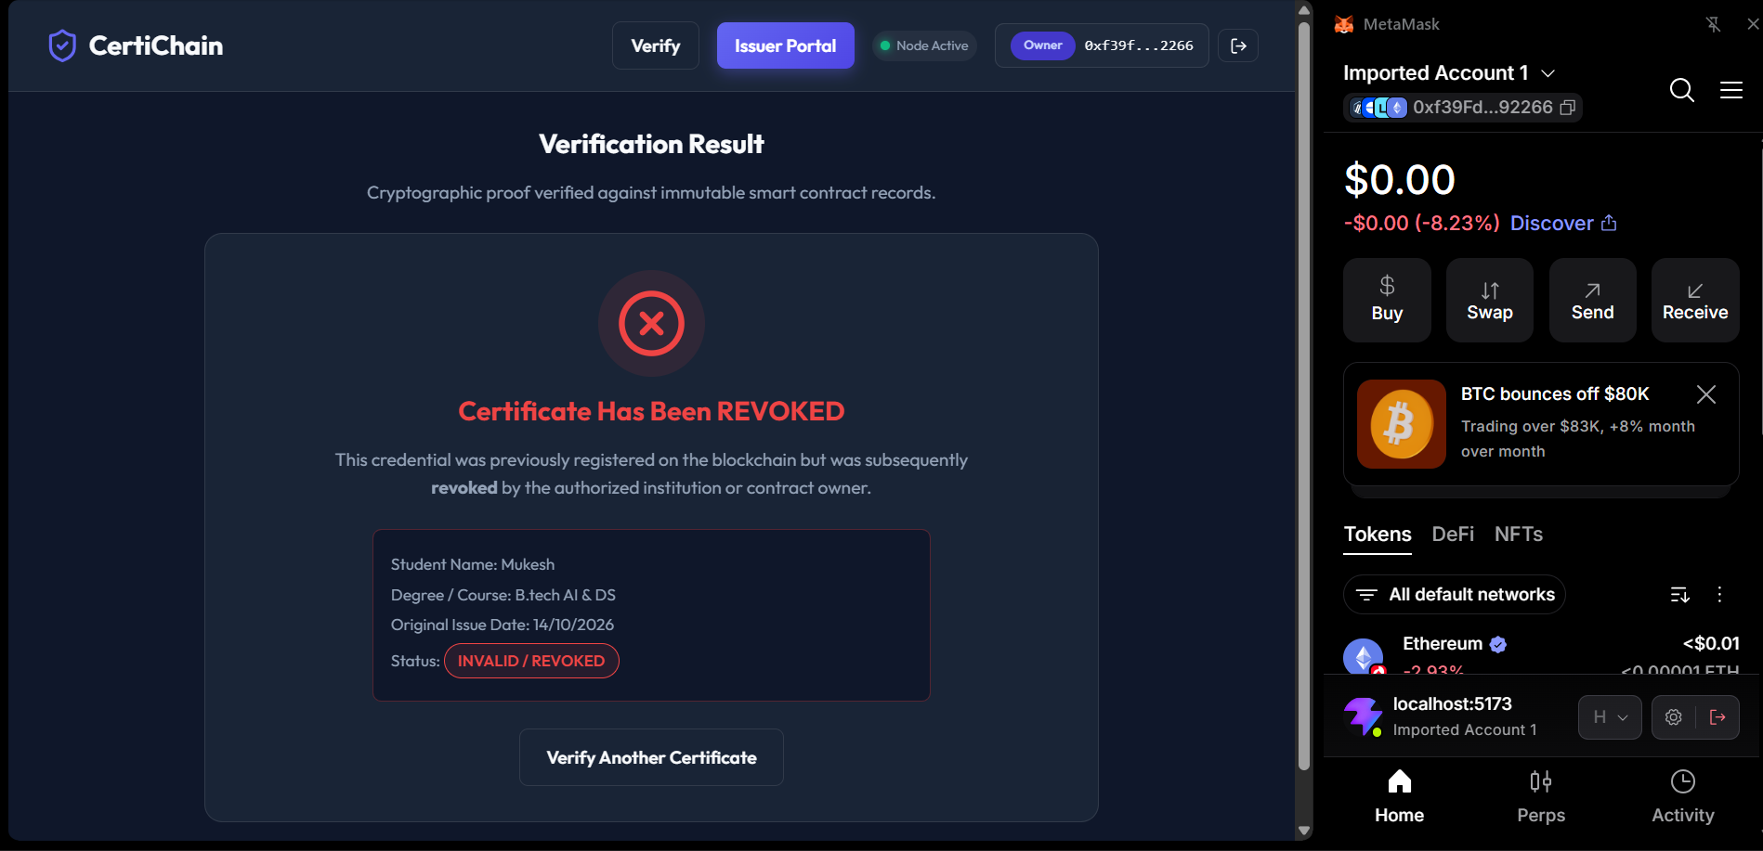
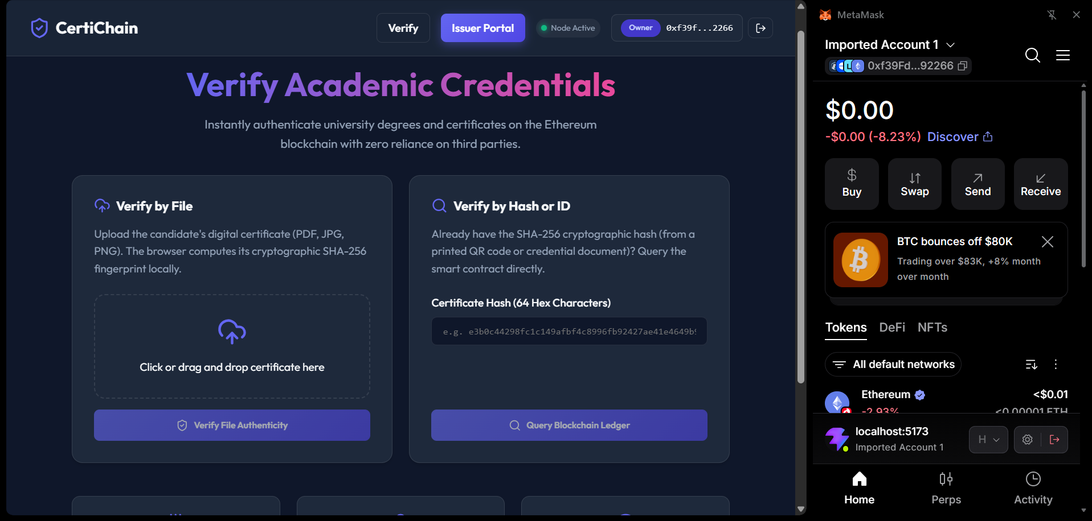

12. Future Scope
- Layer 2 deployment: deploy on a low-fee rollup such as Polygon, Arbitrum, Optimism or Base to reduce registration costs to pennies per certificate.
- Batch registration: register a Merkle root (for example registerBatch(bytes32 merkleRoot)) so a university can issue an entire graduating class in a single transaction.
- Decentralized identifiers and soulbound tokens: issue ERC-5192 / ERC-721 non-transferable tokens to student wallets as verifiable credentials.
- Governance: move ownership to a multi-signature wallet or a consortium of accreditation bodies.
- Storage efficiency: switch keys to bytes32 and add privacy-preserving metadata.

13. Conclusion
CertiChain demonstrates that credential verification can be made instant, trustless and privacy-preserving with a small amount of on-chain data. By hashing documents locally, recording only a fingerprint and minimal metadata on Ethereum, and enforcing issuer permissions in a smart contract, the platform removes the need for slow, manual verification while keeping sensitive documents out of any central store. Verifiers need no wallet or registration, issuers retain control through revocation, and the 14-test suite gives confidence in the contract's access control and life-cycle logic. With Layer 2 deployment, batch issuance and soulbound credentials, the same design can scale from a local prototype to an institution-grade system.

References
- Ethereum Foundation, Ethereum Developer Documentation.
- Solidity Documentation, version 0.8.x.
- Hardhat Documentation.
- Ethers.js v6 Documentation.
- W3C, Web Cryptography API.
- NIST FIPS 180-4, Secure Hash Standard (SHA-256).
- EIP-5192, Minimal Soulbound NFTs.
- React and Vite Documentation.

